**INFO6007 Project Management in IT**

**Group Project**

**Analysis of Field Data Collection Automation project (FDCA)**

**Background**

According to the USA constitution, the decennial census of USA, which collecting data for the country's population and corresponding distribution, is conducted every ten years, it is one of the most important national projects, where the data collected will be used for federal and local governments activities planning. The preparation work for the 2010 Census began from 2000, and because of the “insanely” increasing cost for conducting the census, which was $3.3 billion adjusted to 2000 dollars for the 1990 census, $6.5 billion for the 2000 census, and an estimated cost for the 2010 was $11 billion (2000 Census Lessons Learned for Planning a More Cost – Effective 2010 Census Government Accountability Office, Oct 2002), the U.S. Census Bureau who is responsible for leading and conducting the census, was asked by the Congress to find out a way to cut down the cost. In addition, the traditionally used method for collect statistics was challenged due to the growing population and its diversity, one example is that the 2010 census was reported with an estimated number of 6 million people been missed and 3.6 million been double counted (PricewaterhouseCoopers projects $4.1 billion federal funding loss in 31 states, $3.6 billion for 58 counties–US Census Monitoring Board press release, 7 Aug 2001). Under this case, the COO of the 2010 census, Preston Waite, proposed that, to meet the goal of reducing cost and improving the data accuracy, the current paper-based census method should be redesigned and he decided to equip his 525,000 field workers with handheld GPS device.

The most critical project for achieving this, titled, the Field Data Collection Automation project (FDCA), was focused on development the handheld devices and the software needed and deployment of the devices. The project was estimated to cost $800 million and the initial testing was planned in 2004. In fact, the Bureau staff worked on the architecture for the redesigned census from 2001 to 2004, and in 2006, the Bureau awarded a $600 million contract to Harris Corporation to develop the devices. The project had experienced several scope changes and finally in 2008, it had been announced as failed due to the cost overruns up to $2 billion and the behind of schedule. The main cause for the project failure was believed to be the lack of management and the detailed analysis is shown as below.

Yuming JIANG

**Scope**

Census of all people in US must be conducted every decade according to the US constitution. [1] The huge cost and inaccuracy of the result should be the two main issues in the 1990 census. [1] To solve the problem, the objectives of FDCA project was set to reduce cost and increase accuracy of the census. Significantly, this high level goal of the project was specific, measurable, agreed, realistic and time-enough. [ppt smart]

To explain the scope of the FDCA project in detail, it is better to have the Work Breakdown Structure. However, WBS of FDCA project have not been released by now, so our team tried to collect as much resources about the FDCA project as possible, and summarize all of these resources to determine the WBS shown below.

1.0 Planning

1.1 Project Management

1.2 Scope Management

1.3 Cost Management

1.4 Schedule Management

1.5 Task Management

1.6 Human Resource Management

1.7 Communication Management

1.8 Risk Management

2.0 Design

2.1 Requirement Specification

2.1.1 Conduct Interview and Surveys

2.2 Hardware Development

2.2.1 Operations Control System (OCS)

2.2.2 Hand-Held Computers (HHCs)

2.2.3 Telecommunications Infrastructure

2.3 Software Developing

2.3.1 Capture Address in Software

2.3.2 Display Census-generated information

2.3.3 Assignment Management System software

2.3.4 GPS receiver

2.3.5 Modem for listers

2.4 Set Operations Infrastructure

2.4.1 Local Census office

2.4.2 Regional Census office

3.0 Testing

3.1 Census Test Address Canvassing Operation

3.2 Census Test Address Canvassing Operation

3.3 Census Dress Rehearsal Address Canvassing Operation

4.0 Implementation

4.1 Implement FDCA

4.2 Ensure system is working

5.0 Closing

5.1 Project sign-off

5.2 Post Implementation Review

As shown in the WBS, the FDCA project team first set the project management guideline for the whole project such as setting the scope, estimating the budget and so on. After these things ready, the FDCA project team began to develop Operations Control System (OCS), Hand-Held Computers (HHCs) and Telecommunications Infrastructure. Softwares run in these hardwares were designed at the same time. Three test would be operated in the plan to check the usability of the FDCA project. Finally, the deliverables just like the OCS, HHCs and Telecommunications Infrastructure would be used in the 2010 US Census.

The requirements were also needed to be determined explicitly in the scope management. Our team find that, although the team of the FDCA project specified the needed requirements at first, these requirements were proved that they were either not needed in the implementation or not provided enough and specific criteria for justifying the performance. [1] Furthermore, the Census Bureau kept changing the requirements during the project. [2] The situation was made the worst in 2008, what happened is that the Bureau refocuses themselves and Harris Corp of Melbourne is provided with a list of 400 new or changed requirements for the handheld devices. [1] This meant that almost everything should be designed from the beginning.

In a word, after analyzing the scope management of the FDCA project, ineffective business analysis and failure to establish requirements performance checking criteria in the scope management should be two main issues leading the FDCA project to the failure.

[1] detail read case study

[2] https://montejoer.wordpress.com/2012/03/09/chapter10-case-study-1-the-census-bureaus-outsourcing-debacle/

TIME

Time is one of the most essential aspect of project management, and it is also one of the main reasons on why the FDCA project fails horribly. A proper time management is necessary so the project could keep track on its task and progress. One of the most important tasks in time management is planning the project schedule, in terms of its task, duration, and resources required etc. Keeping track of these tasks allow the project team to know what tasks is currently worked on, and what tasks should be done next. This allows the project team to keep track of both their progress and time. Generally, a gantt chart is usually created to ease the time management process. Although in the FDCA project, the team fails to even create any type of time scheduling documentation. **Figure** below shows an example of a gantt chart based on the project scope.

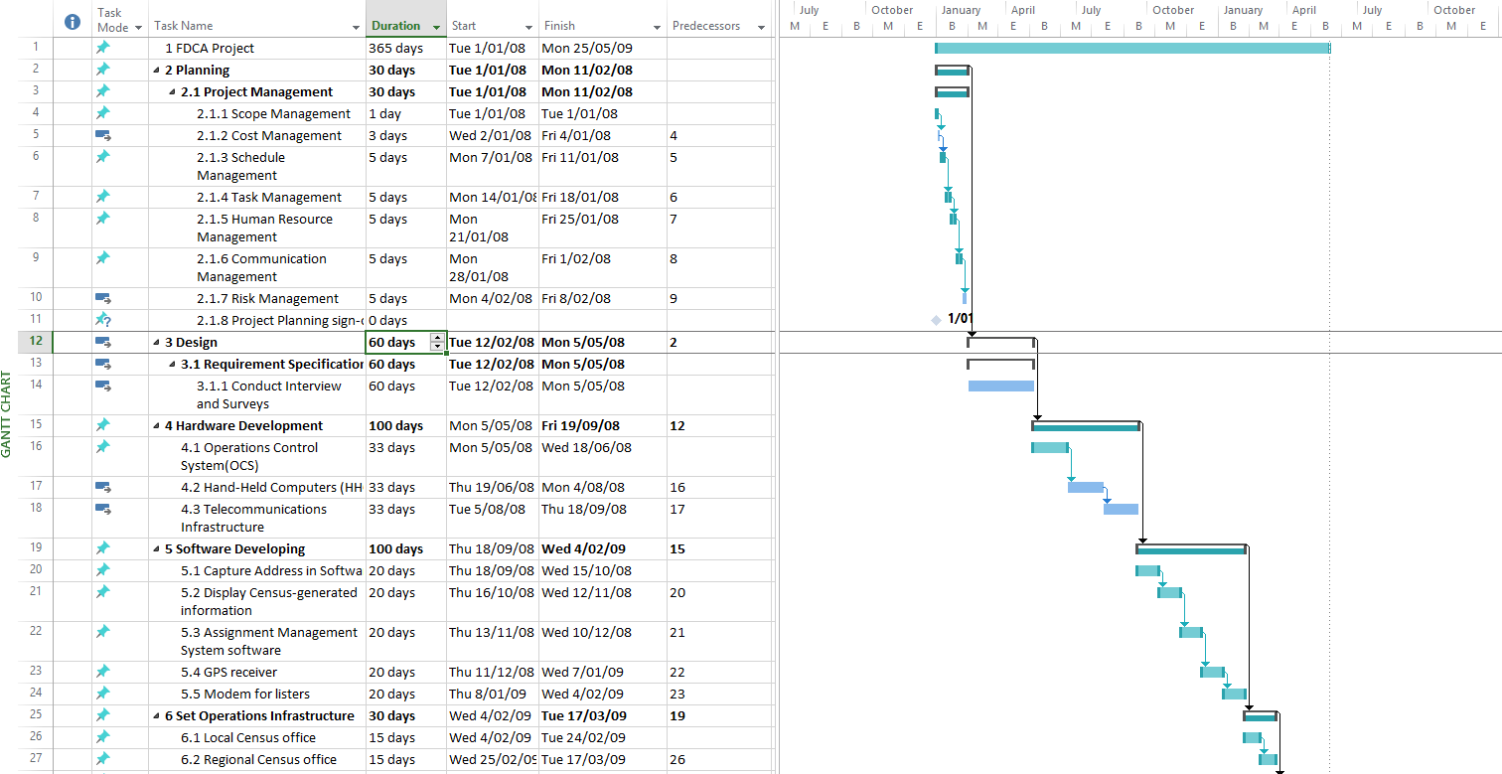

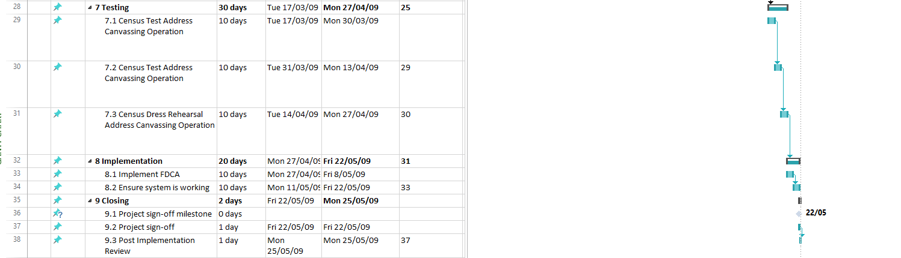

The gantt chart shows the tasks, its dependencies, progress, and resources. The tasks are sequenced based on its dependencies which allows the project team to keep track on task required to be done. It allows everyone on the project team to be on the same page, and prevent future confusions on the tasks, for example, by stating that person A will be doing task 1, and person B will be doing task 2, future confusions will be avoided beforehand.

A project generally should have an estimated time baseline of completion, which allows an estimated time of completion to be produced, which is required for every project. By knowing the estimated completion time, the tasks and its resources can be properly divided. Knowing how long each tasks will take and the resources it requires is very important to ensure completion of the task on schedule. The FDCA project fails to produce these baseline, and during the creation of the project itself, the project planning takes up to 5 years, which is unacceptable even for a project on this scale. The project ends up being dropped due to stakeholders not believing that the project will be successful in terms of effectiveness and worth.

Milestone is another important task in time management especially in a large project like FDCA. Milestones allow project to have significant points and achievements during the project implementation phase which helps the project in terms of motivation and time management. Achieving milestones on time allows the project to see if they are currently on track in terms of estimated schedule. The **Table** below shows an example of possible milestones based on the project scope which the FDCA project also fails to implement.

|  |  |  |
| --- | --- | --- |
| Milestone Name | Date | Completed (Yes/No) |
| Project Planning sign-off | 1/01/08 | ~ |
| Project closing sign-off | 22/05/09 | ~ |

COST

**Quality**

The aim of conducting quality management on IT project is to guarantee the project meets the requirements it should deliver, where involves both the written requirements for the products and the requirements from the real users, which are the enumerators in this case, which is often ignored but indeed critical, since the goal of the project management is to meet the expectations of the stakeholders which include the real users, and also because of this, the quality management is important in project management and should be considered as the same level with the scope, time and cost management of the project. [1]

And for this particular project, considering the census data is an essential factor for building up the political map of the United States [3], the quality of the census data is especially important, as the data will be used for planning federal government activities such as determine the seat numbers of the US House of Representatives and annual federal budget allocation, and also for local government activities such as where to build roads and schools. [2]

According to [4], the quality profile created for 2010 census operations helps measure each operation’s quality, the comparison of quality between automated operation and paper-based operation revealed that the Hand-Held Computers (HHC) did make a contribution to the improvements of the quality of the data, by allowing automated editing and collecting GPS locations and making the word done more quickly and reducing the data transmission time. Furthermore, it is believed that the HHC performed great savings on the cost of paper payroll processes by applying automated payroll. [2010-census evaluation]. However, the test conducted by Census Bureau on the FDCA system on May 1, 2008 revealed that the HHC has significant problems such as running slow, even frozen up sometimes and could not transmit data consistently, and there were also problems with the management program for the field operations.

The reason why the quality of the HHC failed is due to the lack of efficient quality management.

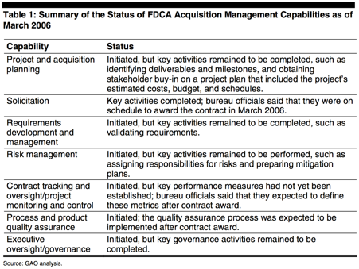

Table 1 Summary of the Status of FDCA Acquisition Management Capabilities as of March 2006

According to [5], shown in Table 1, the U.S. Government Accountability Office (GAO) reported on the FDCA project office had not implemented the needed management activities to manage the process. For the quality management specifically, the FDCA office had not ensured the traceability between the operational requirements and the proposed FDCA requests, which would put the project at risk. And the office had not selected and released the performance measures in detail for track the performance of the contractor and its internal progress.

And further in October 2007, GAO reported that the FDCA program “would not be delivered on schedule and within budget or perform as expected” without effective management. [significant problems of]

[1] Schwalbe, Kathy. Information Technology Project Management, 8th Edition. Cengage Learning, 20151027. VitalBook file.

[2] 2010 Census Planning and Development – P. Jay Waite, Associate Director for Decennial Census – Industry Advisory Council Executive Luncheon, Washington, DC - 17 Mar 2005

[3] case study

[4]

[5]

**Risk**

The 2010 US census program is considered to be of high risk because the size is large and the complexity is high. In order to successfully implement the whole program, risk management is of high importance because it may directly jeopardize the the success of the program. Risk management is the process that is used to identify and mitigate potential problems in a project. There are many tools and concepts that can help people manage the risks, which includes risk management planning, risk register, risk analysis, risk monitoring and controlling. In this program, risk management has not been done well, which may be part of the reason why it failed. In this case study, the process of risk management that US Census Bureau implemented is to be shown and the problem of the risk management process will be analyzed according to the risk management document.

It was the first time that a census program implemented a formal risk management process in the US.(https://www.census.gov/2010census/pdf/2010_Census_Risk_Management_Process_Assessment.pdf) Seven major categories of risks were generally identified, which were staffing, budget, public cooperation, quality risk, operations and system, continuity of operations and schedule. (RRRRR ) The Risk Review Board (RRB), who was responsible for defining, accepting and evaluating the risks were set up, which helps control the risks, manage process and increase efficiency. The formal risk management was planned to start in 2007. However, the risk management plan was not formulated until June 2008. The risk management plan is used to estimate potential risks, define the impacts and consider certain responses. Since the late release of risk management plan, the risk management process also postponed and then the control of risk may be more difficult. Since risk management plan was released, the risk management team paid main attention to risk analysis. The use of risk analysis is to control the risk through the project lifetime. Specific team members should be responsible for the risk analysis and the risk control. Then the team planned more on risk mitigation plans, which was drawn up once a month by risk manager. In the risk management plan, one of the important components is risk register. Risk register is also a risk management tool that risk managers use to follow identified risks, understand their impacts and consider mitigation and contingency solutions in a document format. The risk register should contain risk descriptions, dates, probability of occurrence, impact, status, mitigation and contingency solutions. Another risk management tool which is important in risk management is the mitigation plan, which helps a project strengthen opportunities and lower threatens.(https://www.mitre.org/publications/systems-engineering-guide/acquisition-systems-engineering/risk-management/risk-mitigation-planning-implementation-and-progress-monitoring) In a case study, Montejo (2012) proposed that one of the causes of the project is the failure to locate responsibility for risks and formulate risk mitigation plans properly. (https://montejoer.wordpress.com/) In mitigation plans, there are four types of response that risk manager can propose to use in accordance to the specific risks, which are avoidance, mitigation, transfer, acceptance. Contingency plans were also used in this project, but team members often confused it with mitigation plan. Contingency plans are the ones that people execute when an obvious warning sign is shown and do not change the impact and probability of occurrence of the risks while the use of mitigation plan is to reduce the impact and probability of occurrence. (http://www.izenbridge.com/blog/know-the-difference-between-mitigation-plan-and-contingency-plan/) The major difference in executing both plans is that mitigation plan takes the actions before the risk condition while the contingency plan takes the actions after.

Through the process of the 2010 US Census Program, the risk manager should take responsibility for the poor management in risk management. First, vague roles and responsibilities in risk management may contribute to the failure of the whole program. Another area is on scheduling and misunderstanding risk management concepts. The late release of risk management plan and misunderstanding of mitigation plan and contingency plan may also cause big problems.